Sri Lanka Institute of Information

Technology



Lab Submission

Lab sheet No _09

**Nimsara V K V**

**IT24103528**

**Probability and Statistics | IT2120**

B.Sc. (Hons) in Information Technology

Exercise

Instructions: Create a folder in your desktop with your registration number

(Eg: ”IT.......”). You need to save the R script file and take screenshots of the command prompt with answers and save it in a word document inside the folder. Save both R script file and word document with your registration number (Eg: ”IT........”). After you finish the exercise, zip the folder and upload the zip file to the submission link.

1. Assume that the time taken to bake a batch of cookies is normally distributed with mean 45 minutes and standard deviation 2 minutes.

i. Generate a random sample of size 25 for the baking time.

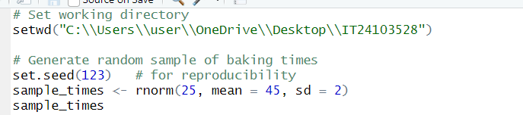

ii. Test whether the average baking time is less than 46 minutes at a 5% level of significance



